

BOOT loader

Operating Systems Lab(BCSE303P)



***Name: Chillara V L N S Pavana Vamsi***

***Register Number: 21BCE5095***

1. Write a boot loader program that prints A using Print Character procedure

|  |
| --- |
| [BITS 16]  [ORG 0x7C00]  MOV AL,65  CALL Printcharacter  MOV AL,77  CALL Printcharacter  MOV AL,83  CALL Printcharacter  MOV AL,73  CALL Printcharacter  JMP $  Printcharacter: ;Procedure to print character on screen  MOV AH,0x0E ;Tell the BIOS that we need to print one character on screen  MOV BH,0x00 ;page no  MOV BL,0x07 ;tell attribute 0x07 is lightgrey font on black background  INT 0x10 ;call vedio interrupt  RET ;return to calling procedure  TIMES 510 -($ -$$) db 0  DW 0xAA55 |

1. Write a boot loader program that prints A directly   by performing lodsb and or operations

bits 16

org 0x7c00

boot:

mov si,hello

mov ah,0x0e

.loop:

lodsb

or al,al

jz halt

int 0x10

jmp .loop

halt:

cli

hlt

hello: db "A",0

times 510 -($ -$$) db 0

dw 0xaa55

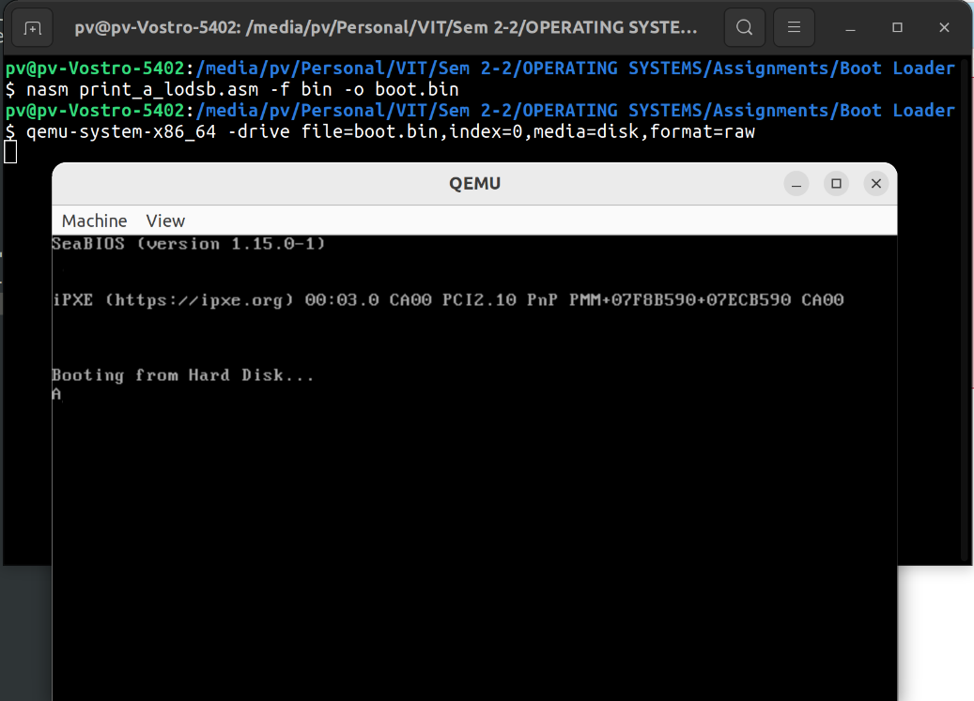

1. Write a boot loader program that prints your name

bits 16

org 0x7c00

boot:

mov si,hello

mov ah,0x0e

.loop:

lodsb

or al,al

jz halt

int 0x10

jmp .loop

halt:

cli

hlt

hello: db "21BCE5095 Chillara V L N S Pavana Vamsi",0

times 510 -($ -$$) db 0

dw 0xaa55

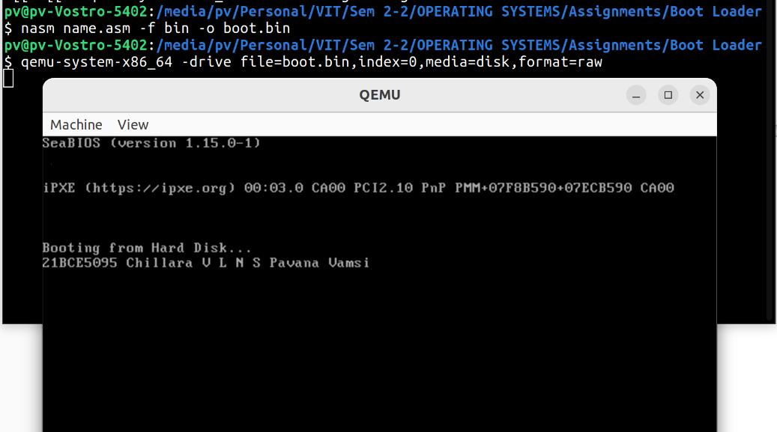

1. write a boot loader program to print your registration number using print character procedure as well as lodsb and or operations. (21bce with print character and your number 1001 with lodsb => so 21bce1001 is the final display)

[BITS 16]

[ORG 0x7C00]

MOV AL,50

CALL Printcharacter

MOV AL,49

CALL Printcharacter

MOV AL,66

CALL Printcharacter

MOV AL,67

CALL Printcharacter

MOV AL,69

CALL Printcharacter

boot:

mov si,hello

mov ah,0x0e

.loop:

lodsb

or al,al

jz halt

int 0x10

jmp .loop

halt:

cli

hlt

hello: db "5095",0

JMP $

Printcharacter: ;Procedure to print character on screen

MOV AH,0x0E ;Tell the BIOS that we need to print one character on screen

MOV BH,0x00 ;page no

MOV BL,0x07 ;tell attribute 0x07 is lightgrey font on black background

INT 0x10 ;call vedio interrupt

RET ;return to calling procedure

TIMES 510 -($ -$$) db 0

DW 0xAA55

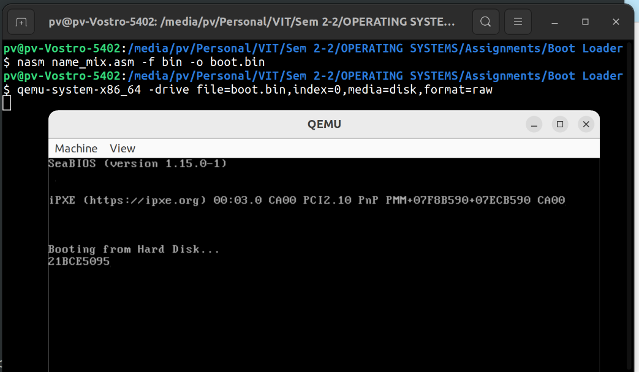

1. Write a boot loader program to print your name in red colour.

[bits 16]

[org 7c00h]

jmp main

main:

xor ax,ax ;ds=0

mov ds,ax

cld ;df=0 because our lodsb requires it

mov ax,0012h

int 10h

mov si,string

mov bl,5 ;red

call printstr

jmp $

printstr:

mov bh,0 ;display page

print:

lodsb

cmp al,0

je done

mov ah,0Eh ;BIOS teltype

int 10h

jmp print

done:

ret

string db "21BCE5095 Chillara V L N S Pavana Vamsi",13,10,0

times 510 -($ -$$) db 0

dw 0AA55h

